

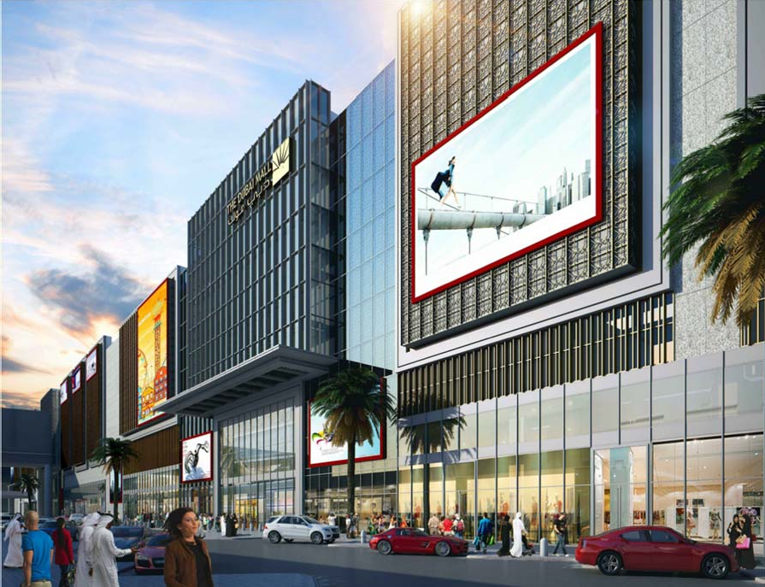
TDMZE
THE DUBAI MALL ZA’ABEEL EXTENSION OPERATIONS & MAINTENANCE MANUAL VOLUME 1 of 1
PART 1 of 1

SCISSOR LIFT

Page no.
2
7
9
12
14
16
21
24
28
35
37
40
42
44
46
48
54
56
58
59

INDEX
SECTION 01. ABOUT THE PROJECT SECTION 02. CHANGE CONTROL
SECTION 03. EMERGENCY ESCALATION PROCEDURE SECTION 04. EMERGENCY INFORMATION
SECTION 05. EMERGENCY EQUIPMENT LOCATIONS SECTION 06. SYSTEM PURPOSE AND SCOPE
SECTION 07. CONTRACTUAL AND LEGAL INFORMATION SECTION 08. DESCRIPTION
SECTION 09. EQUIPMENT SCHEDULES AND ASSET REGISTERS SECTION 10. OPERATING INSTRUCTIONS AND PROCEDURES
SECTION 11. METHOD STATEMENT FOR PIT MOUNTING OF SCISSOR LIFT
SECTION 12. MAINTENANCE PROCEDURES
SECTION 13. SPARE PARTS AND REPLACEMENT PARTS

SECTION 14. DISPOSAL INSTRUCTIONS

SECTION 15. TESTING AND COMMISSIONING DATA

SECTION 16. MODIFICATIONS

SECTION 17. DRAWINGS

SECTION 18. MANUFACTURER AND SUPPLIER LITERATURE

SECTION 19. PRODUCT GUARANTEES AND WARRANTIES

SECTION 20. CROSS REFERNECE INDEX

1

SECTION 1

ABOUT THE PROJECT

2

1. ABOUT THE PROJECT

The Dubai Mall Za’abeel Extension (TDMZE) is an expansion to the existing Dubai Mall which increases the footprint of the mall by 40% by connecting the two structures with bridges that cross the Financial Centre Road elevated multilane highways at a high level (level 6).

TDMZE consists of retail and car parking.

TDMZE building provides additional parking to the existing Dubai Mall as well as a substantial increase in retail (including 3 new anchor tenants), food and beverage areas and restaurants. There is also provision for a future 50+ storey residential tower to be integrated into this project.

The floor-wise space breakdown is provided below:

- P1: Ground Floor

  - Utility Rooms, Fire Command Center, Fire Corridors, Police Rooms and MEP Services Rooms and Ramp Access

  - Retail along South Elevation

  - Loading Docks

  - Service Lifts, Main Lobby, Toilets and Lift Lobbies.

  - DEWA Corridor

- P2: Mezzanine

  - Typical Carpark Floor

  - Lift Lobbies and Stairs

  - MEP Service Rooms

- P3: First Floor

  - Typical Carpark Floor

  - Public and Residential Parking

  - Escalator Lobbies and Taxi Waiting Area

  - Lift Lobbies and Stairs

  - MEP shafts and Riser

- P4: Second Floor

  - Typical Carpark Floor

  - Public and Residential Parking

  - Escalator and Lift Lobbies

  - Male and Female Prayer rooms, Ablution and Public Toilets

  - Stairs and MEP Service Rooms

Emaar Properties PJSC

Section 1

Facilities Management 3

- P5: Third Floor

  - Retail and Carpark Floor

  - Escalator and Lift Lobbies

  - Stairs and MEP Service Rooms

- P6: Fourth Floor

  - Retail and Carpark Floor

  - Flagship Tenant, F&B, Foodcourt, Entertainment and Public Toilets

  - Ped Link Bridge to The Dubai Mall (NIC)

- P7 & P8 Fifth and Sixth Floors

  - Retail and Carpark Floor

  - Escalator and Lift Lobbies

  - Stairs and MEP Service Rooms

- P9: Roof Slab

  - Typical Carpark Floor

  - Escalator and Lift Lobbies

  - Stairs and MEP Service Rooms

  - Residential Amenities (NIC)

Emaar Properties PJSC Section 1
Facilities Management 4

SECTION 2

CHANGE CONTROL .

Emaar Properties PJSC Section 2
Facilities Management
5
CHANGE CONTROL

DATE | SYSTEM | MANUAL  SECTION | DESIGN BY | DETAILS OF  CHANGE
5 Jan 2019 | Mechanical | SCISSOR LIFT | NIHVA TECHNOLOGIES PVT. LTD. | Revision 00
03 Apr 2019 | Mechanical | SCISSOR LIFT | NIHVA TECHNOLOGIES PVT. LTD | Revision 01

Emaar Properties PJSC Section 2
Facilities Management 6

SECTION 3

EMERGENCY ESCALATION PROCEDURE
3.1 FM ESCALATION CHART FOR MAJOR BREAKDOWNS …

Emaar Properties PJSC Section 3
Facilities Management 7

FM Escalation Chart for Major Breakdowns

Emaar Properties PJSC Section 3
Facilities Management 8
SECTION 4

EMERGENCY INFORMATION
  - EMERGENCY CONTACTS
  - PROJECT DIRECTORY

Emaar Properties PJSC Section 4
Facilities Management 9

EMERGENCY INFORMATION

Emergency Contacts

In case of | Contact | Telephone
Accident or Incident | Police | Tel: 999
Fire | Fire Brigade | Tel: 997
Medical Emergency | Ambulance Or Police | Tel: 998 / 999
Power Failure | DEWA | Tel: 04-3244 444  Fax: 04-3248 111  Email: csd@dewa.gov.ae
Telephone Enquiry | ETISALAT | Tel: 181

Project Directory

Role | Organization Name &  Address | Phone/Fax & E-Mail  Details
 | Emaar Properties PJSC | Tel: +971 4 367 3333
 | P O Box 9440 | Fax: +971 4 367 3000
Employer | Dubai | E-mail: ffadda@emaar.ae
 | United Arab Emirates
 | Dubai Municipality | Tel: +971 4 221 5555
 | P O Box 67 | Fax: +971 4 224 6666
Local Authority | Dubai | E-mail: info@dm.gov.ae
 | United Arab Emirates
 | Turner Construction - | Tel: +971 4 3675609  Fax: +971 4 3348216  E-mail:
 | International Middle East | Tel: +971 4 3675609  Fax: +971 4 3348216  E-mail:
 | Ltd. | Tel: +971 4 3675609  Fax: +971 4 3348216  E-mail:
Project Manager | P.O. Box 13036 | Tel: +971 4 3675609  Fax: +971 4 3348216  E-mail:
 | Dubai,  United Arab Emirates | Tel: +971 4 3675609  Fax: +971 4 3348216  E-mail:
Lead Consultant | Brewer Smith Brewer Gulf PO Box 50667  Dubai United Arab Emirates | Tel: +971 4 294 2042  Fax: +971 4 294 2101  E-mail:  enquiries@bsbgulf.com

Emaar Properties PJSC Section 4
Facilities Management 10

Role | organization Name &  Address | Phone/Fax & E-Mail  Details
 | Omnium International | Telephone: +9714 3434600  Fax: +971 4 3437142  Email: dubai@omniumint.com
 | Limited
Quantity Surveyor | P.O. Box 62256
 | Dubai,
 | United Arab Emirates
 | Dutco Construction Co LLC | Tel: +971 4 880 1010
Main Contractor | P O Box 8944  Dubai | Fax: +971 4 880 1515  E-mail: mail@dbb.ae
 | United Arab Emirates
 | ASSA ABLOY Entrance | Tel: +971 4 8852888
Installing Contractors Details | Systems P.O.Box 80983  Dubai | Fax: +971 4 8854919  E-mail:  info.ae.entrance@assaabloy.com
 | United Arab Emirates
Maintenance Contractors  Details | Will be decided at a later stage

Emaar Properties PJSC Section 4
Facilities Management 11

SECTION 5

EMERGENCY EQUIPMENT LOCATIONS .

Emaar Properties PJSC Section 5
Facilities Management 12

EMERGENCY EQUIPMENT LOCATIONS

For the location of general emergency equipment such as fire alarm call points, etc. Please refer to the Fire Detection and Alarm System O&M manual and the Fire Fighting System O&M manual

Emaar Properties PJSC Section 5
Facilities Management 13

SECTION 6
SYSTEM PURPOSE AND SCOPE
  - PURPOSE OF THE INSTALLATION

Emaar Properties PJSC Section 6
Facilities Management 14

SYSTEM PURPOSE AND SCOPE

Purpose of the Installation

The NIHVA hydraulic scissor lift ensures below purpose.

Provide safe lifting to the loading bay area.

Provides most economic dependable & versatile methods of lifting loads…

This lift table raises load smoothly to any desired height.

Emaar Properties PJSC Section 6
Facilities Management 15

SECTION 7
SECTION 7
CONTRACTUAL & LEGAL INFORMATION
  - CONTRACTUAL & LEGAL INFORMATION
  - TEST CERTIFICATES
  - OPERATIONAL HAZARDS
  - HAZARD PROTECTION
  - SAFETY PRECAUTIONS

Emaar Properties PJSC Section 7
Facilities Management 16

CONTRACTUAL & LEGAL INFORMATION

Installation Start Date
ASSA ABLOY Entrance Systems
Sub-Contractor(s)
ASSA ABLOY Entrance Systems
Installation Contractors
Consultants

Contractual & Legal Information
Legal information

The Dubai Mall Zaabeel Expansion
System Address
EMAAR Properties PSJC
System Ownership

Design Team
BSBG
Brewer Smith Brewer Gulf (BSBG)

Practical completion date
Installed

Finished
Warranty / DLP Agent
The date of the taking over certificate

From the date of the taking over certificate
Warranty Expiry Date
DLP Expiry Date
ASSA ABLOY Entrance Systems

Test Certificates

Please refer to attached certificates.

Operational Hazards

- Lift should not be loaded beyond its rated load capacity.
- Don’t lose the oil hoses without resting the lift on its maintenance stoppers.
- Do not operate damaged lift.

Emaar Properties PJSC Section 7
Facilities Management 17

- Don’t stand at the edges of lift platform while the lift is lowering.
- Don’t change lowering valve setting without supervision or any assistance.
- In case of power failure, to resume the downward operation after Power ON, do not lower the lift. Instead, take the lift slightly upward & then resume to lower it.
- Don’t put any manual stopper or anything in the roller track.

Hazard Protection

Check all the electrical connections

Check the hydraulic connections.

Ensure NO OIL leakage from joints.

Ensure the oil level on level indicator before using the lift.

Before loading and unloading ensure the lip rests on truck properly.

While doing maintenance work, ensure that the emergency switch is pressed & maintenance stoppers are in their position while working below the lift.

Safety Precautions

Use trained personnel for loading & unloading of equipment. The equipment must be properly handled when transferring from the unloading area to final site to prevent damage.
DO NOT operate equipment unless it is properly anchored. It may cause serious injury or death.
- Install all safety devices, guards and guarding prior to equipment start-up.

- Only Trained & Authorized person must use the lift.

- Always use mechanical stopper if you are going to work in elevated condition.

- Keep working area free from oil to Avoid Slipping/Fire hazards.

- Do Not Exceed the Lift Capacity than rated.

- Before cleaning or servicing disconnect power supply

Emaar Properties PJSC Section 7
Facilities Management 18

- As the lift moves up and down, “pinch points” are formed. Keep hands, feet, hair, loose clothing, etc. away from these pinch points. Any of these may cause serious personal injury or death.

- Ensure that the hydraulic, pneumatic and electrical lines will not be pinched by the lift as it rises or lowers. If a line gets pinched, the lift may not work properly. A hose may break, the lift table may drop suddenly, and someone may get injured. If an electrical line is broken, may cause personal injury or death due to electrical shock.

- Read the motor nameplate and record the motor full load current. Consult local electrical codes for power supply fusing requirements. To avoid fire hazards, follow these fusing requirements.



Emaar Properties PJSC Section 7
Facilities Management 19



.

Emaar Properties PJSC Section 7
Facilities Management 20

SECTION 8

8. Description

  - System Description
  - Operating Instruction

Emaar Properties PJSC Section 8
Facilities Management 21

DESCRIPTION

System Description
- The hydraulic scissor lift load capacity rating and the serial number (NSCL 325) is mentioned on metal name plate.
- Lift should not be overloaded beyond the rated load capacity may result in damage.
- The hydraulic system consists of pump, motor, oil tank & valves.
- The gear pump is set at operating pressure of 200 bar.
- The operating principle is that the pump is operated to raise the table, and the pump is stopped when the table attains the desired elevation. A check valve and lowering valve between the pump and cylinder holds the table at elevation. For lowering to any desired level, the solenoid valve is energized to allow fluid to return from hydraulic cylinder to reservoir. A pressure compensated flow control valve is connected to the hydraulic cylinder to control the down speed at a predetermined rate under all load conditions.
- A scissor lift should only be operated on a solid surface such as concrete, tile, or a compacted road base. When lifts are placed on uneven surfaces or earth, mulch or gravel that is not compacted, the lifts may tip and fall over, causing serious injury or death.

Emaar Properties PJSC Section 8
Facilities Management 22

MAIN SPECIFICATIONS
A) Maximum Load Lifting Capacity | 9000 KG
B) Max Height of Platform | 1960 MM
C) Actual Lift | 1500 MM
D) Min Height of Platform | 460 MM
E) Platform Length | 3000 MM
F) Platform Width | 2000 MM
G) Motor Capacity | 10 HP
H) Oil Tank Capacity | 100 LTR

Operating Instructions

- Check all electrical connection for short or phase short. Check hydraulic connections are tightened properly to ensure no oil leakage from joints.
- Connect (3 phase 415V) supply to the panel through cable top.
- Switch ON the RED LOTO SWITCH on panel & ensure Emergency push button is in unlock position.
- Use Lift’s PUSH BUTTONS for moving lift upward & downward.
- Use Lip’s PUSH BUTTONS for moving lip upward & downwards. Do not operate the Lip when the platform is below the level of floor / when the platform is under the pit.
- In case of emergency, press emergency STOP push button provided on push button station.
- Before lifting Scissor, check motor rotates in clock wise direction.
- For controlling the lowering speed, adjust the valve provided on manifold.
- In case of failure & scissor lift platform is at top position, loosen the threads of manual override provided in the solenoid valve after reaching the platform at down position again retighten the same.

Emaar Properties PJSC Section 8
Facilities Management 23

SECTION 9

EQUIPMENT SCHEDULES & ASSET REGISTERS
  - EQUIPMENT SCHEDULE
EQUIPMENT NAME
REFERENCE AND LOCATION
  - ASSET REGISTER

Emaar Properties PJSC Section 9
Facilities Management 24

EQUIPMENT SCHEDULES & ASSET REGISTERS

9.1 Equipment Schedule

Equipment Name

Manufacturer | NIHVA TECHNOLOGIES PVT. LTD. PUNE, INDIA
- Equipment Name | SCISSOR LIFT
B) Maximum Load Lifting capacity | 9000 KG
C) Max. Height of Platform | 1960 MM
D) Actual Lift | 1500 MM
E) Min Height of Platform | 460 MM
F) Platform Length | 3000 MM
G) Platform Width | 2000 MM
H) Motor Capacity | 10 HP
I) Oil Tank Capacity | 100 LTR

Emaar Properties PJSC Section 9
Facilities Management 25

Reference and Location
S. No. | Reference | Model | System / Area Served | Location
1. | Drawing Ref.  TDMZE- AES-AR-SDG-Z01-P01-1001 | KHDL 710-20 | Scissor Lift / Loading area | Ground floor – Gridline 2/ E to E’
2.
3.
4.

Emaar Properties PJSC section 9
Facilities Management 26

  - Asset Register

Will be provided during final submission.

 |  |  |  | Location |  |  |  |  |  |  | Sub-Contractor |  | Warranty Period
 | Description |  |  |  |  |  |  |  |  |  | Sub-Contractor |  | Warranty Period
Asset Ref | Description | Category | Building | Level | Area | Room No. | Make | Model | Serial No. | Quantity | Sub-Contractor | Supplier | Warranty Period
 | SCISSOR LIFT | LOADING EQUIPMENT | P1 | GROUND FLOOR | GOODS LOADING AREA |  | ASSA ABLOY | KHDL 710 - 20 | ME12850 | 1 |  |  | 1 year
 |  |  |  |  |  |  |  |  |  |  | ASSA ABLOY Entrance Systems | ASSA ABLOY Entrance Systems

Emaar Properties PJSC Section 9
Facilities Management 27

SECTION 10

OPERATING INSTRUCTIONS AND PROCEDURES
  - START-UP PROCEDURE
  - NORMAL OPERATION
  - INSPECTION CHECK POINTS
  - HEALTH & SAFETY
  - TROUBLE SHOOTING GUIDELINES
  - SAFETY CHECK LIST

_____________________________________________________________________________________
Emaar Properties PJSC Section 10
Facilities Management 28
OPERATING INSTRUCTIONS AND PROCEDURES

Start-up procedure

- Check all electrical connection for short or phase short. Check hydraulic connections are tightened properly to ensure no oil leakage from joints.
- Connect (3 phase 415V) supply to the panel through cable top.
- Switch ON the RED LOTO SWITCH on panel & ensure Emergency push button is in unlock position.
- Use Lift’s PUSH BUTTONS for moving lift upward & downward.
- Use Lip’s PUSH BUTTONS for moving lip upward & downwards.
- In case of emergency, press emergency STOP push button provided on push button station.
- Before lifting Scissor, check motor rotates in clock wise direction.
- For controlling the lowering speed, adjust the valve provided on manifold.
- In case of failure & scissor lift platform is at top position, loosen the threads of manual override provided in the solenoid valve after reaching the platform at down position again retighten the same.

Normal operation

- Check all the electrical connections.
- Check the hydraulic connections.
- Ensure NO Oil Leakage from joints.
- Ensure the oil level on level indicator before using the lift.
- Before loading & unloading ensure the lip rests on truck properly.
- Ensure that there isn’t any obstacle within the region of moving parts.
- While doing maintenance work, ensure that the Emergency switch is pressed & the maintenance stoppers are in their position while working below the lift.
- During brake down condition, use the LOTO switch.
_______________________________________________________________________________________
Emaar Properties PJSC Section 10 Facilities Management 29

Inspection Checkpoints
INSPECTION- BEFORE OPERATION- once
- Visually inspect all jack pins, pivot pins to ensure that the set screw has not loosened, allowing pins to move.
- Confirm Hex Nut Bolt, Allen Bolt -Pivot Pin Locking are Fixed firmly.
- Confirm Grub screw, Cup Washer on Scissor Arm Joint Bolt are fixed & are tightened firmly.
- Confirm Tightening of Rollers & its free movement.
- Confirm all Bolts at Scissor Arm are tightened.
- Visually inspect all lift arm rolling bearings to ensure that bearing bolts are tight.
- Visually inspect all hydraulic hoses and fittings to ensure there are no cut on hoses or leaking fittings.
- Visually inspect all electrical lines to ensure there are no cut wires or loose cords.
- Visually inspect the entire lift structure.
- These recommendations are applicable to the equipment considering daily usage of approx. 15-to 20 times.
- If usage is more frequent, the same time intervals for maintenance should be adjusted accordingly.
WEEKLY
- Do greasing / oiling of all moving joints.
MONTHLY
- Check hydraulic pipeline for leak proof working.
- Check oil level in hydraulic tank.
- Check cylinder seals & ‘O` rings for leak proof working.
YEARLY
- Change hydraulic oil.
- Check main shaft seal & shaft ‘O` ring for leak proof working.
- Hydraulic oil to be used – Enclo – 68 OR Servo – 68.

________________________________________________________________________________________
Emaar Properties PJSC Section 10
Facilities Management 30

Health & Safety

Use trained personnel for loading & unloading of equipment. The equipment must be properly handled when transferring from the unloading area to final site to prevent damage.
DO NOT operate equipment unless it is properly anchored. It may cause serious injury or death.

- Install all safety devices, guards and guarding prior to equipment start-up.

- Only Trained & Authorized person must use the lift.

- Always use mechanical stopper if you are going to work in elevated condition.

- Keep working area free from oil to Avoid Slipping/Fire hazards.
- Do Not Exceed the Lift Capacity than rated.

- Before cleaning or servicing disconnect power supply

- As the lift moves up and down, “pinch points” are formed. Keep hands, feet, hair, loose clothing, etc. away from these pinch points. Any of these may cause serious personal injury or death.

- Ensure that the hydraulic, pneumatic and electrical lines will not be pinched by the lift as it rises or lowers. If a line gets pinched, the lift may not work properly. A hose may break, the lift table may drop suddenly, and someone may get injured. If an electrical line is broken, may cause personal injury or death due to electrical shock.

- Read the motor nameplate and record the motor full load current. Consult local electrical codes for power supply fusing requirements. To avoid fire hazards, follow these fusing requirements.

________________________________________________________________________________________
Emaar Properties PJSC Section 10
Facilities Management 31

___________________________________________________________________________________________________
Emaar Properties PJSC Section 10
Facilities Management 32

Trouble shooting Guidelines

- If lift will not raise:
- Check electric circuit on new installations of 3-phase motors, if lift does not start raising in approximately 10 seconds, reverse two power supply leads to reverse pump rotation. (if motor direction is reverse)
- Check oil level. With lift in full up position, oil level should be
- Approximately 11⁄4" above tank bottom.

- Lift raises slower than specified rate or will raise only partial load:
Note: Allowance must be maintained for slight speed variations (due to temperature which changes the viscosity of the hydraulic oil varies)
- Check line voltage under load condition. Low voltage affects capacity of equipment.
- If foam is visible in tank oil, check for a loose connection in suction line between pump and tank. Tighten connections.

iii. Lift slowly settles with lowering valve not energized:
- Flush lowering valve by cycling lift up and down. This should be done with no load.
- If lift continues to settle, replace down valve cartridge.
- If lift continues to settle, replace pump.

iv. If Lift will not lower:
- Look for mechanical restrictions.
- Test valve coil for operation. Check voltage at coil.
- If voltage is ok, replace coil.

v. If lift will not raise to full vertical travel:
a. Check for low oil level if necessary, add oil.

__________________________________________________________________________________________________
Emaar Properties PJSC Section 10
Facilities Management 33

vi. If lift does not lower smoothly:
- Run the lift up and down under load condition for some time to purge air.

Safety Check List

- Leakage at Piping –
    - Tighten Joints.
    - Replace Dotty Seal at Mounting

- Leakage in Cylinder-
- Replace Seals.

- Replace Oil after Every Year-
- Drain the Oil from the System.
- Clean filter, Tank elements, and strainers before refilling.

_______________________________________________________________________________
Emaar Properties PJSC Section 10
Facilities Management 34

SECTION 11

- Installation Procedure for scissor lift

_______________________________________________________________________________
Emaar Properties PJSC Section 11
Facilities Management 35

Method Statement for Pit Mounting of scissor lift

- Check all pit dimensions for accuracy.
- Attach a temporary electrical line through the pit conduit to the lift. Check for correct motor rotation
- Using slings, encircle the entire lift, not just the platform and lower the lift into the pit, centering it for 1” minimum clearance on all sides to the pit wall.
- Raise the lift with the push button and remove the slings. Run the unit up and down several times to remove air from the hydraulic system.
- Level and center the lift by shimming and grouting the entire base frame, not just the corners. Lag the unit in place using M16 x 150L wedge anchors in the holes provided. Caution! Continuous base frame support is essential for proper installation
- With the lift fully elevated, disconnect the main power and complete the permanent electrical wiring.
- After completion of electrical wiring, place the scissor lift in the pit safely.

___________________________________________________________________________
Emaar Properties PJSC Section 11
Facilities Management 36

SECTION 12

MAINTENANCE PROCEDURES
  - PLANNED MAINTENANCE PROCEDURES
  - PLANNED MAINTENANCE SCHEDULES

___________________________________________________________________________
Emaar Properties PJSC Section 12
Facilities Management 37

MAINTENANCE PROCEDURES

Planned Maintenance Procedures


Lubrication Points
Lubrication points as mentioned below,
- Points noted with ‘A’, apply grease lubrication.
- Points noted with ‘B’, apply oil lubrication.
- Points noted with ‘C’, no lubrication required (Pre-Lubricated &sealed)
- Ensure all Moving parts like Wheel, Flap Joint, Rollers etc. are greased.

___________________________________________________________________________
Emaar Properties PJSC Section 12
Facilities Management 38

Maintenance Procedure for Powerpack & Control Panel
Powerpack-
- Check the oil level periodically.
- Take sample of oil in beaker & check the color. If it becomes dark blackish in color, change the oil.
- Check the leakages on powerpack.
- If leakages are found, change ‘o’ rings of respective valves.
- Take out the filter TIF 28, clean it quarterly.
- If the return line filter clogging indicator is giving red indication, change the filter element.
- Check all the joints for leakages by hand. If oil is leaking somewhere, tighten that particular joint.
- Check the hoses for wrinkles and cracks. If found leaking change the same.
Control Panel-
- Open the control panel and clean with blower to remove dirt if any, once in six months.
- Check all the components in control panel visually for any abnormality once in an year.
- Check all the connections for looseness of wires at tightening points, if found ensure firm grips by tightening the screws.

Planned Maintenance Schedules

- WEEKLY
- Do greasing / oiling of all moving joints.

- MONTHLY
- Check hydraulic pipeline for leak proof working.
- Check oil level in hydraulic tank.
- Check cylinder seals & ‘O` rings for leak proof working.

- YEARLY
- Change hydraulic oil.
- Check main shaft seal & shaft ‘O` ring for leak proof working.
- Hydraulic oil to be used – Enklo – 68 OR Servo system– 68.

___________________________________________________________________________
Emaar Properties PJSC Section 12
Facilities Management 39
SECTION 13

SPARE AND REPLACEMENT PARTS

___________________________________________________________________________
Emaar Properties PJSC Section 13
Facilities Management 40

- SPARE AND REPLACEMENT PARTS

 |  |  |  |  |  |  |  |  | 1 | S. No.
 |  |  |  |  |  |  |  |  |  | Recommended
 |  |  |  |  |  |  |  |  |  | Actual Installed
 |  |  |  |  |  |  |  |  | Electro Mechanical | System
 |  |  |  |  |  |  | Power Pack | Control Panel | Scissor Lift | Part Description And Model Number
 |  |  |  |  |  |  | Ground floor grid 1-E to E’ |  |  | Location / Area
 |  |  |  |  |  |  | 1 |  |  | Units Issued
 |  |  |  |  |  |  | ASSA ABLOY Entrance Systems |  |  | Supplier
 |  |  |  |  |  |  |  |  |  | Delivery period to site from order
 |  |  |  |  |  |  |  |  |  | Current Unit Price (AED)
 |  |  |  |  |  |  | Not applicable |  |  | Shelf Life or special storage conditions

___________________________________________________________________________
Emaar Properties PJSC Section 13
Facilities Management 41

SECTION 14

DISPOSAL INSTRUCTIONS 2
14.1 MAINTENANCE DISPOSAL / DEMOLITION 2

___________________________________________________________________________
Emaar Properties PJSC Section 14
Facilities Management 42

DISPOSAL INSTRUCTIONS

14.1 Maintenance Disposal / Demolition

___________________________________________________________________________
Emaar Properties PJSC Section 14
Facilities Management 43

SECTION 15
TESTING & COMMISSIONING DATA 2

___________________________________________________________________________
Emaar Properties PJSC Section 15
Facilities Management 44

TESTING & COMMISSIONING DATA

The final Testing and Commissioning Data is attached.

___________________________________________________________________________
Emaar Properties PJSC Section 15
Facilities Management 45

SECTION 16

MODIFICATIONS 2
16.1 MANUFACTURERS MODIFICATION DETAILS 2

___________________________________________________________________________
Emaar Properties PJSC Section 16
Facilities Management 46

MODIFICATIONS

Manufacturers Modification Details

NA

Designers Modification Details

NA

___________________________________________________________________________
Emaar Properties PJSC Section 16
Facilities Management 47

SECTION 17

AS BUILT DRAWINGS 2

___________________________________________________________________________
Emaar Properties PJSC Section 17
Facilities Management 48

AS BUILT DRAWINGS

The final As-built drawings will be included in the Final Submission of this O&M Manual.

Drawing No. | Drawing Title / Description
TDMZE-AES-AR-SDG-Z04-P01-1001 | Electro Hydraulic Scissor Lift
NIHVA/18-19/VDR/291 | POWER PACK
NIHVA/18-19/VDR/292 | HYDRAULIC CIRCUIT
NIHVA/18-19/VDR/288 | ELECTRICAL CIRCUIT

___________________________________________________________________________
Emaar Properties PJSC Section 17
Facilities Management 49

- HYDRAULIC POWER PACK & CIRCUIT: -
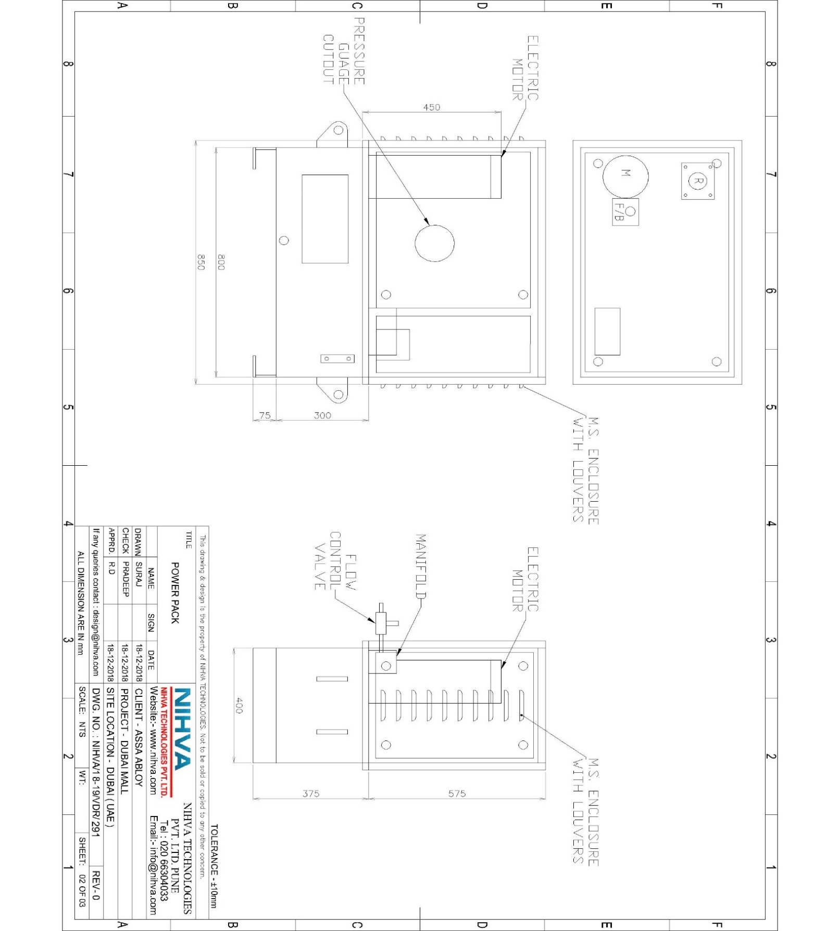
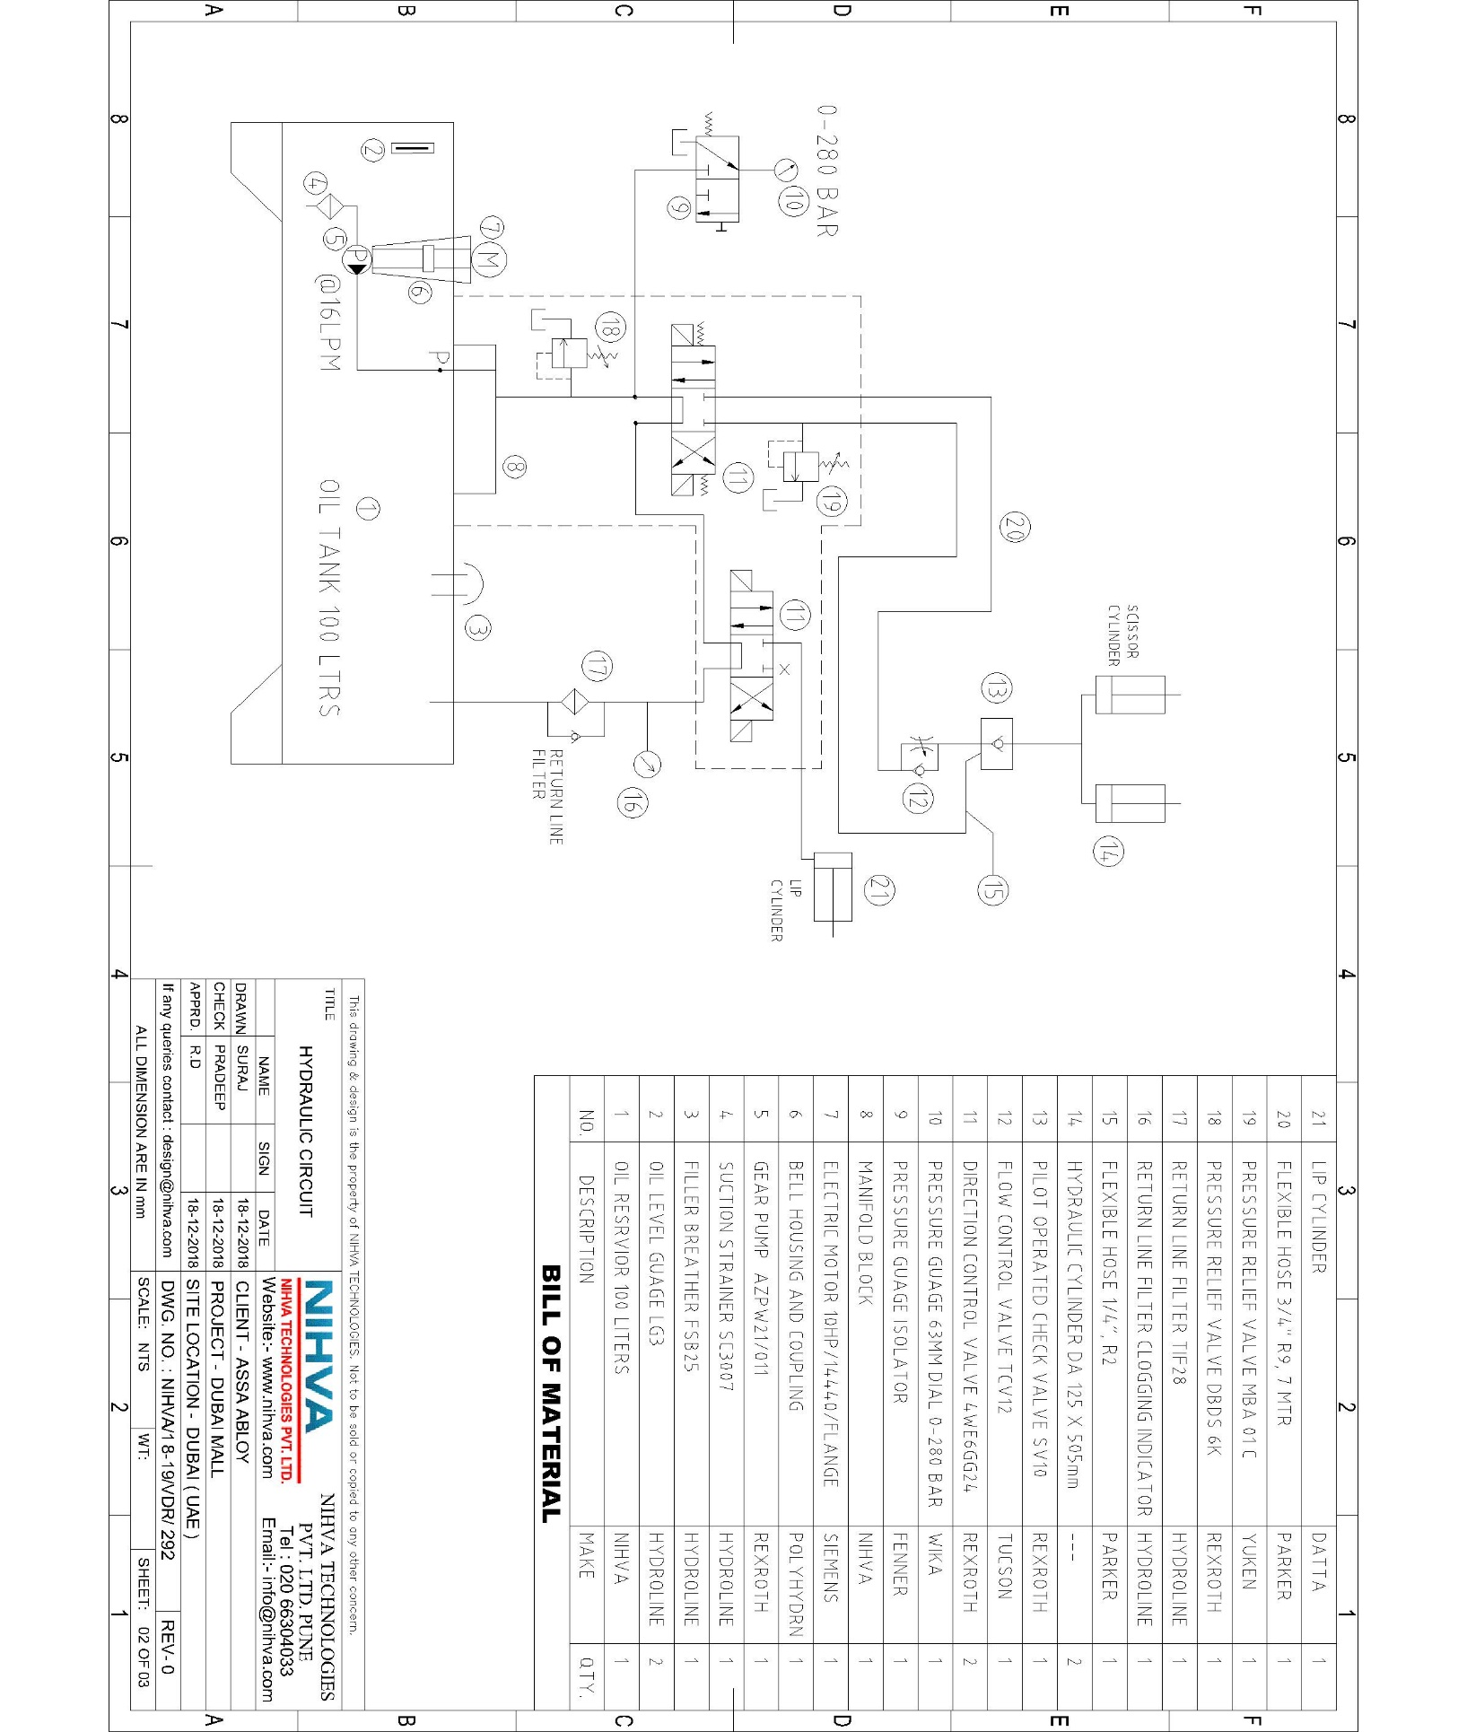
- ELECTRICAL CIRCUIT:-

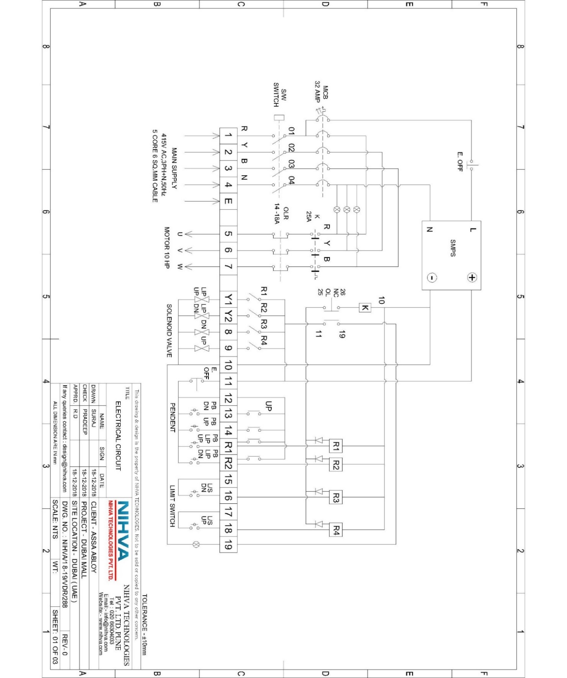

SECTION 18

MANUFACTURER AND SUPPLIER LITERATURE

___________________________________________________________________________
Emaar Properties PJSC Section 18
Facilities Management 54

18. MANUFACTURER AND SUPPLIER LITERATURE

Manufacturers’ Literature Index
Manufacturer /  Equipment | Supplier | Contact Details
NIHVA TECHNOLOGIES PRIVATE LIMITED, PUNE 411019, INDIA | Supplier: | Tel: +912066304033  E-mail: info@nihva.com  Web: www.nihva.com
 | ASSA ABLOY Entrance
 | Systems UAE
 | P O Box 80983
 | Dubai
 | United Arab Emirates
Manufacturer :

NIHVA TECHNOLOGIES PRIVATE LIMITED, PUNE, INDIA

G-BLOCK, 1ST FLOOR, THERMAX CHOWK
MIDC, ABOVE RENAULT SHOWROOM
CHINCHWAD, PUNE-411019, INDIA

Publication Details | No. of Pages
User Manual for Scissor Lift

___________________________________________________________________________
Emaar Properties PJSC Section 18
Facilities Management 55

SECTION 19

PRODUCT GUARANTEES & WARRANTIES
19.1 WARRANTEE LETTERS

___________________________________________________________________________
Emaar Properties PJSC Section 19
Facilities Management 56

PRODUCT GUARANTEES & WARRANTIES
19.1 Warrantee Letters

All Warranty Letters will be Included in the Final Submission of this O&M Manual.

___________________________________________________________________________
Emaar Properties PJSC Section 19
Facilities Management 57

SECTION 20

CROSS REFERENCING INDEX

___________________________________________________________________________
Emaar Properties PJSC Section 20
Facilities Management 58

CROSS REFERENCING INDEX
Our Project Reference number is ME12850

___________________________________________________________________________
Emaar Properties PJSC Section 20
Facilities Management 59

